DEPARTMENT OF

# COMPUTER SCIENCE & ENGINEERING

## **“Experiment 2.3”**

1. **Aim:**

## T**o display data generated by sensor on LCD using Arduino/Raspberry Pi**.

1. **Objective:**

* Learn about Arduino Uno.
* Learn about IoT programming.

1. **Components Required:**

You will need the following components –

* Arduino Uno
* LCD
* Breadboard
* Jumper Wires

1. **Procedure**:

#### **Interfacing 16×2 LCD to Arduino uno:**

LCD modules form a very important part in many arduino based embedded system designs. So, the knowledge on interfacing LCD module to arduino is very essential in designing embedded systems. This section of the article is about interfacing an Arduino to 16×2 LCD. JHD162A is the LCD module used here. JHD162A is a 16×2 LCD module based on the HD44780 driver from Hitachi. The JHD162A has 16 pins and can be operated in 4-bit mode (using only 4 data lines) or 8-bit mode (using all 8 data lines). Here we are using the LCD module in 4-bit mode. First, I will show you how to display a plain text messages on the LCD module using arduino and then, I have designed a useful project using LCD and arduino – a digital thermometer. Before going in to the details of the project, let’s have a look at the JHD162A LCD module.

DEPARTMENT OF

# COMPUTER SCIENCE & ENGINEERING

1. **Code:**

#include<LiquidCrystal.h>

LiquidCrystal lcd(12, 11, 5, 4, 3, 2); // sets the interfacing pins

void setup()

{

lcd.begin(16, 2); // initializes the 16x2 LCD

}

void loop()

{

lcd.setCursor(0,0); //sets the cursor at row 0 column 0

lcd.print("16x2 LCD MODULE"); // prints 16x2 LCD MODULE

lcd.setCursor(2,1); //sets the cursor at row 1 column 2

lcd.print("Sumit"); // prints HELLO WORLD

}

1. **Output:**

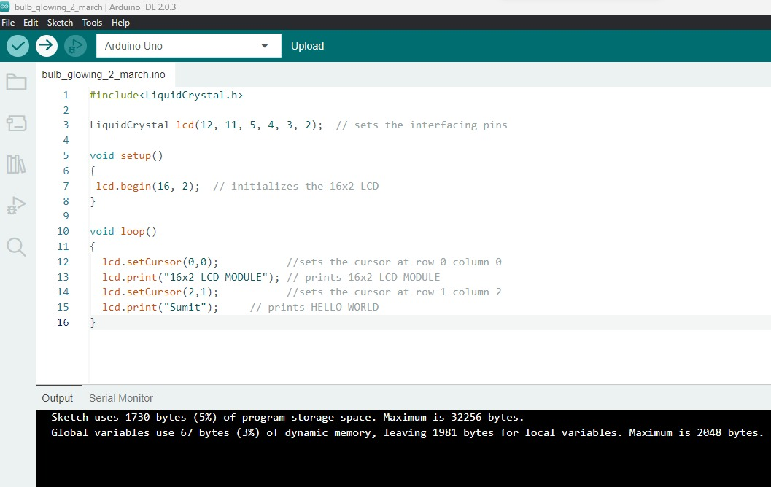

DEPARTMENT OF

# COMPUTER SCIENCE & ENGINEERING

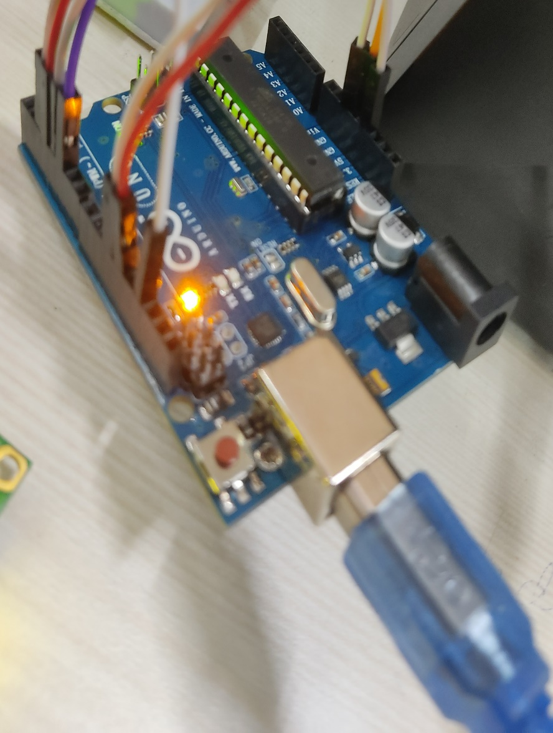

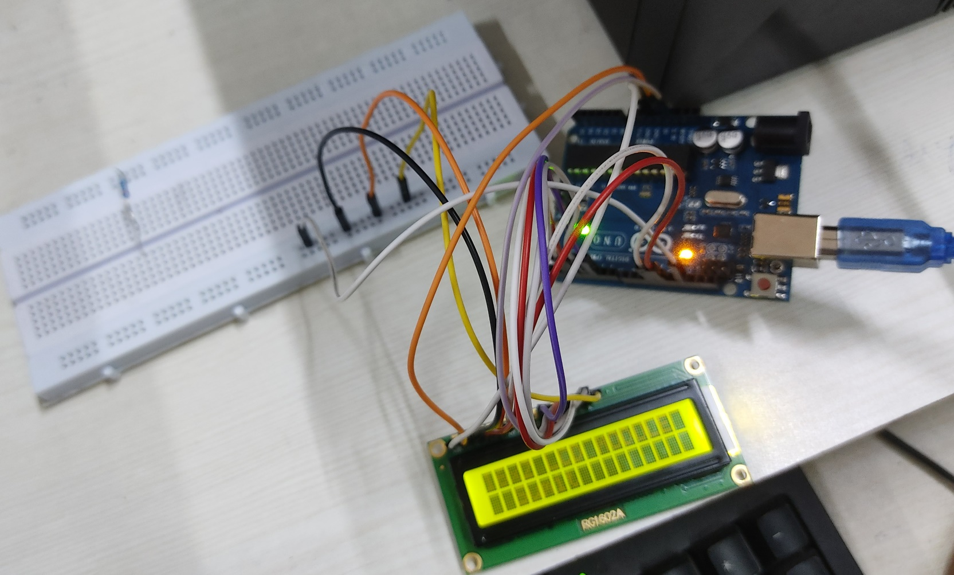

DEPARTMENT OF

# COMPUTER SCIENCE & ENGINEERING

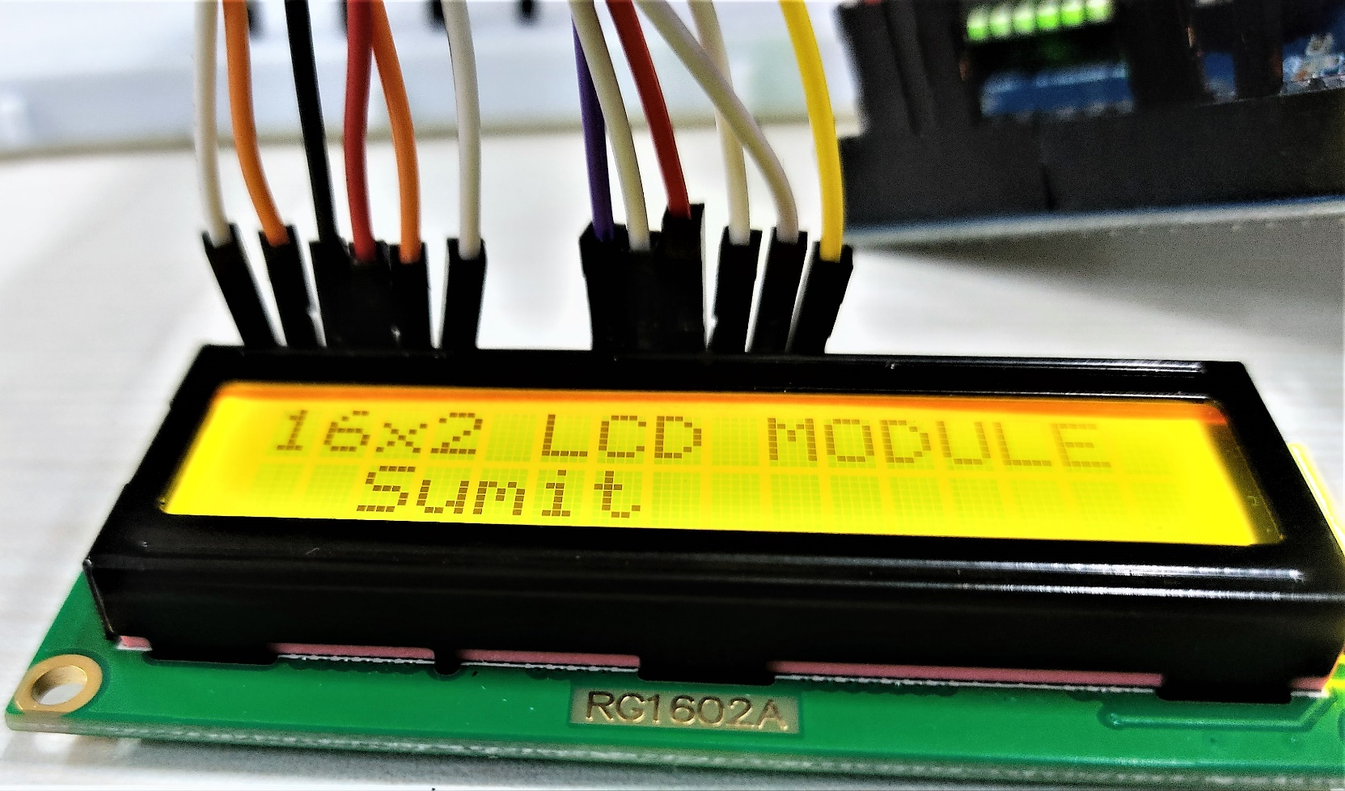

**Learning outcomes (What I have learnt):**

* Learnt about displaying text on LED screen.
* Learnt about IoT programming.
* Learnt about the working of Arduino Uno.